MONACO ANGEL FILM AWARDS : 21th to 24th February 2020
Code “MEET”

SINGLE (one Person) |  |  | DOUBLE (two Person)
Superior Riviera Room | 140 € |  | Superior Riviera Room | 160 €
Superior Garden Room | 155 € |  | Superior Garden Room | 175 €
Superior Exécutive Room | 185 € |  | Superior Exécutive Room | 205 €

Rate per night with American buffet breakfast included

Sales conditions are restricted : no cancellation, no modification, full prepayment at the booking.
Deadline for reservation 30th January 2020

After this date, we will no longer be able to guarantee the availability of rooms. Room type subject to availability.

1 - Go to our website www.accorhotels.com
2 - Complete the fields: where are you travelling to? (Novotel Monte Carlo), dates of stay (arrival,
departure), number of rooms, number of adults
3 - Click on "Additional criteria (preferential code, services...)" and insert « MEET » in the field
'preferential code' -- 4 - Click on “Search”

5 - You will be routed directly to the preferential rate for the Angel Film Awards named "meeting event rate"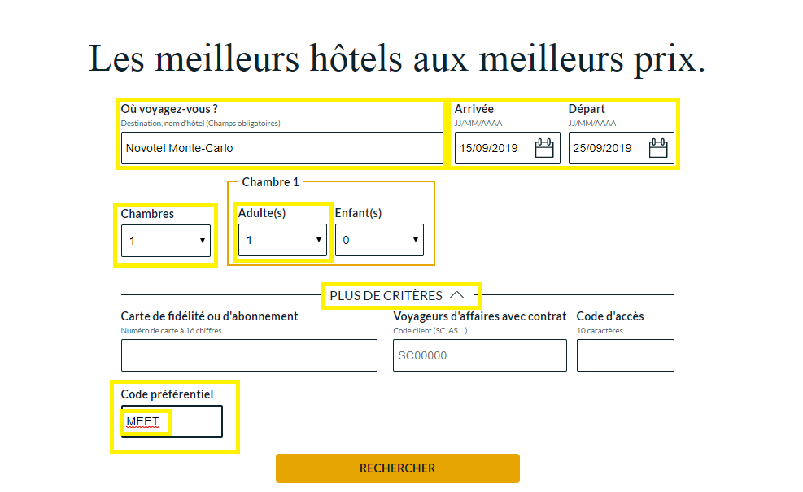

PRESS FIND :

This window will appear :

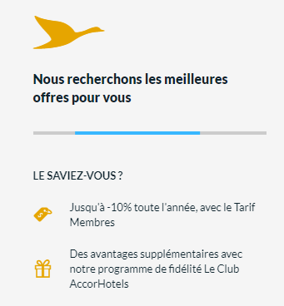

Your Rate will appear this way called « SPECIAL RATE- NO FLEX BB» with breakfast included.

